Project: Creating an IPsec site to site VPN tunnel using Packet Tracer

Project Overview
The purpose of this project it to design and implement a secure , multisite network using Cisco Packet .The project covers the creation of a network topology , configuration of IP addressing on all devices , and implementation of a dynamic routing protocol.
In addition to standard connectivity , the project focuses on establishing a secure IPsec VPN between sites. Security Configuration include enabling the security technology package , creating extended ACLs to control access and configuring Internet Key Exchange Phase 1 and 2 policies to create secure IPsec tunnels. A crypto map is applied to router interfaces to ensure encrypted traffic between sites. All configurations will be validated by testing inter site communication to ensure that data can be securely traverse the VPN while meeting the access control requirements

Requirements
Create network Topology and label interface addresses and Site names
Configure OSPF for routing between the WAN interfaces and Test communication
Configure IPSEC VPN
- Enable security technology package
- Configure an Extended ACL permitting the target on each router
- Configure the IKE Phase 1 ISAKMP policy on each router
- Configure the IKE Phase 2 IPsec policy on each router
- Configure the crypto map on the outgoing interface

Structure
Devices
Router | Switch | End Devices
2911 (3x) | 2960 (2x) | PC-PT (4x)

Modules for Routers
HWIC-2T added to each router for Serial WAN connectivity

Address Plan
WAN IP Addressing
Device | IP Address | Subnet Mask
Site A Router | 10.10.10.2 | 255.255.255.248
Site B Router | 20.20.20.2 | 255.255.255.248
ISP Router | 10.10.10.1 | 255.255.255.248
ISP Router | 20.20.20.1 | 255.255.255.248

LAN IP Addressing
Site | Device | Interface | IP Address | Subnet Mask
Site A | Router | Gig0/0 | 192.168.10.1 | 255.255.255.224
Site A | PC1 | FE0/1 | 192.168.10.2 | 255.255.255.224
Site A | PC2 | FE0/2 | 192.168.10.3 | 255.255.255.224
Site B | Router | G0/0 | 172.168.0.1 | 255.255.255.224
Site B | PC1 | FE0/1 | 172.168.0.2 | 255.255.255.224
Site B | PC2 | FE0/2 | 172.168.0.3 | 255.255.255.224

Configurations
Adding HWIC-2T Module
This is done all on three routers
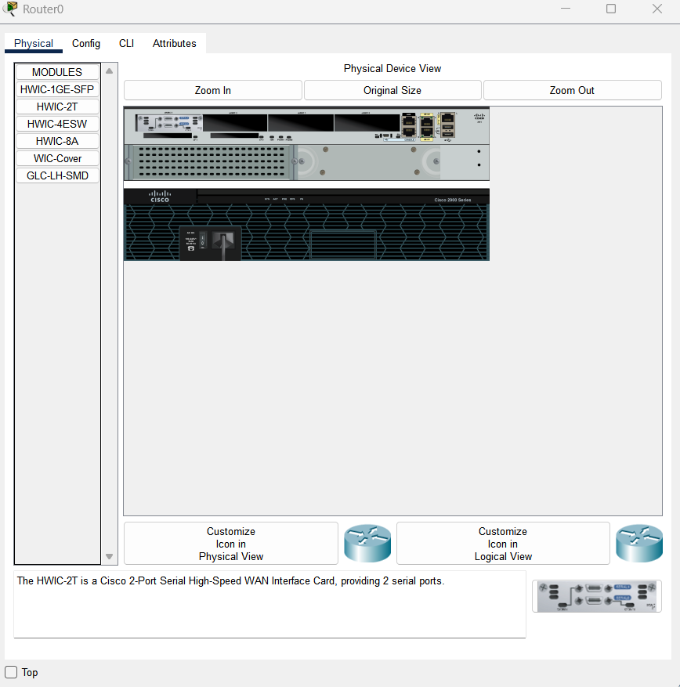

Topology
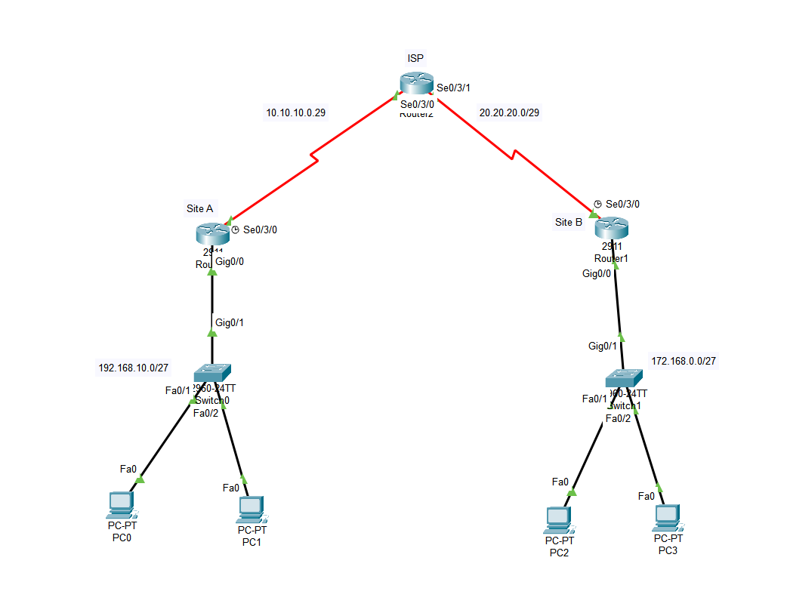

OSPF Configuration
Site A
Router>en
Router#config t
Enter configuration commands, one per line. End with CNTL/Z.
Router(config)#router ospf 1
Router(config-router)#router-id 2.1.2.1
Router(config-router)#network 10.10.10.0 0.0.0.7 area 0
Router(config-router)#network 192.168.10.0 0.0.0.31 area 0
Router(config-router)#exit

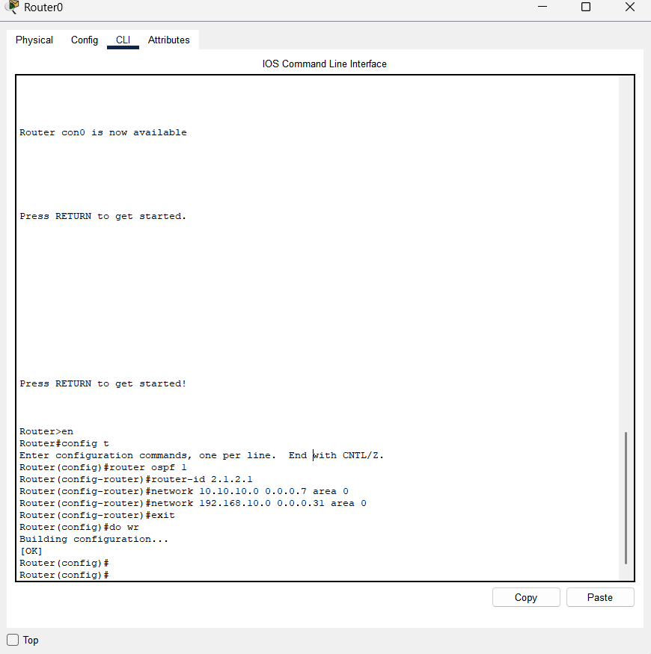

ISP OSPF Configuration
Router>en
Router#config t
Enter configuration commands, one per line. End with CNTL/Z.
Router(config)#router ospf 1
Router(config-router)#router-id 3.1.3.1
Router(config-router)#network 10.10.10.0 0.0.0.7 area 0
Router(config-router)#network
00:24:09: %OSPF-5-ADJCHG: Process 1, Nbr 2.1.2.1 on Serial0/3/0 from LOADING to FULL, Loading Do
% Incomplete command.
Router(config-router)#network 20.20.20.0 0.0.0.7 area 0
Router(config-router)#exit
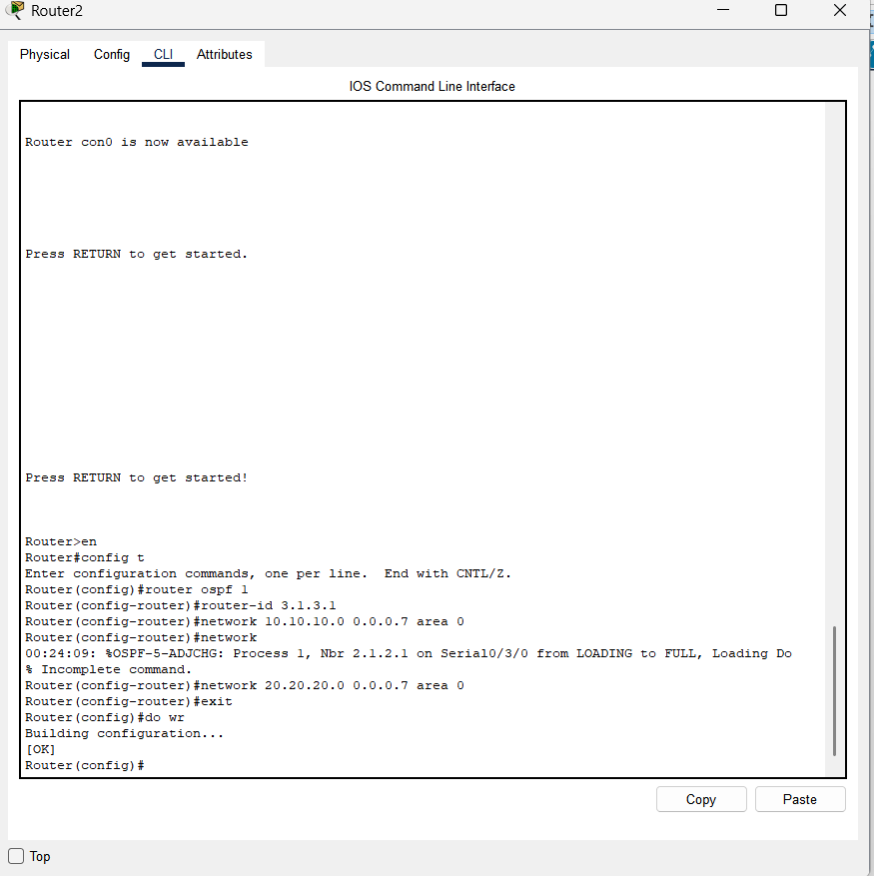

Site B OSPF configuration
Router>en
Router#config t
Enter configuration commands, one per line. End with CNTL/Z.
Router(config)#router ospf 1
Router(config-router)#router-id
% Incomplete command.
Router(config-router)#router-id 4.1.4.1
Router(config-router)#network 172.168.0.0 0.0.0.31 area 0
Router(config-router)#network 20.20.20.0 0.0.0.7 area 0
Router(config-router)#exit

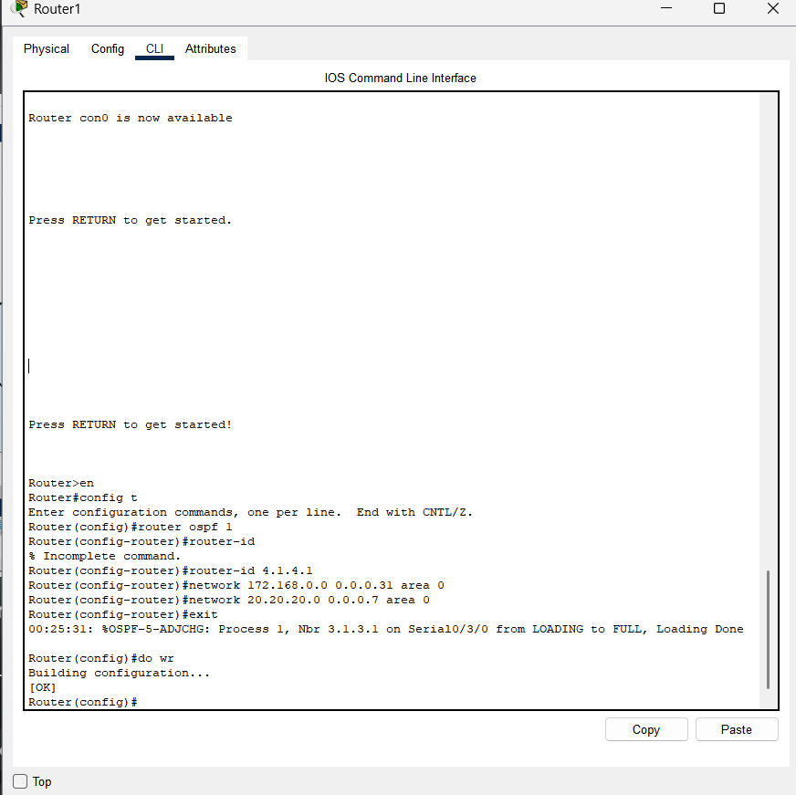

Testing Connectivity between the two sites
From Site A
Ping 172.168.0.2

From Site B
Ping 192.168.10.2
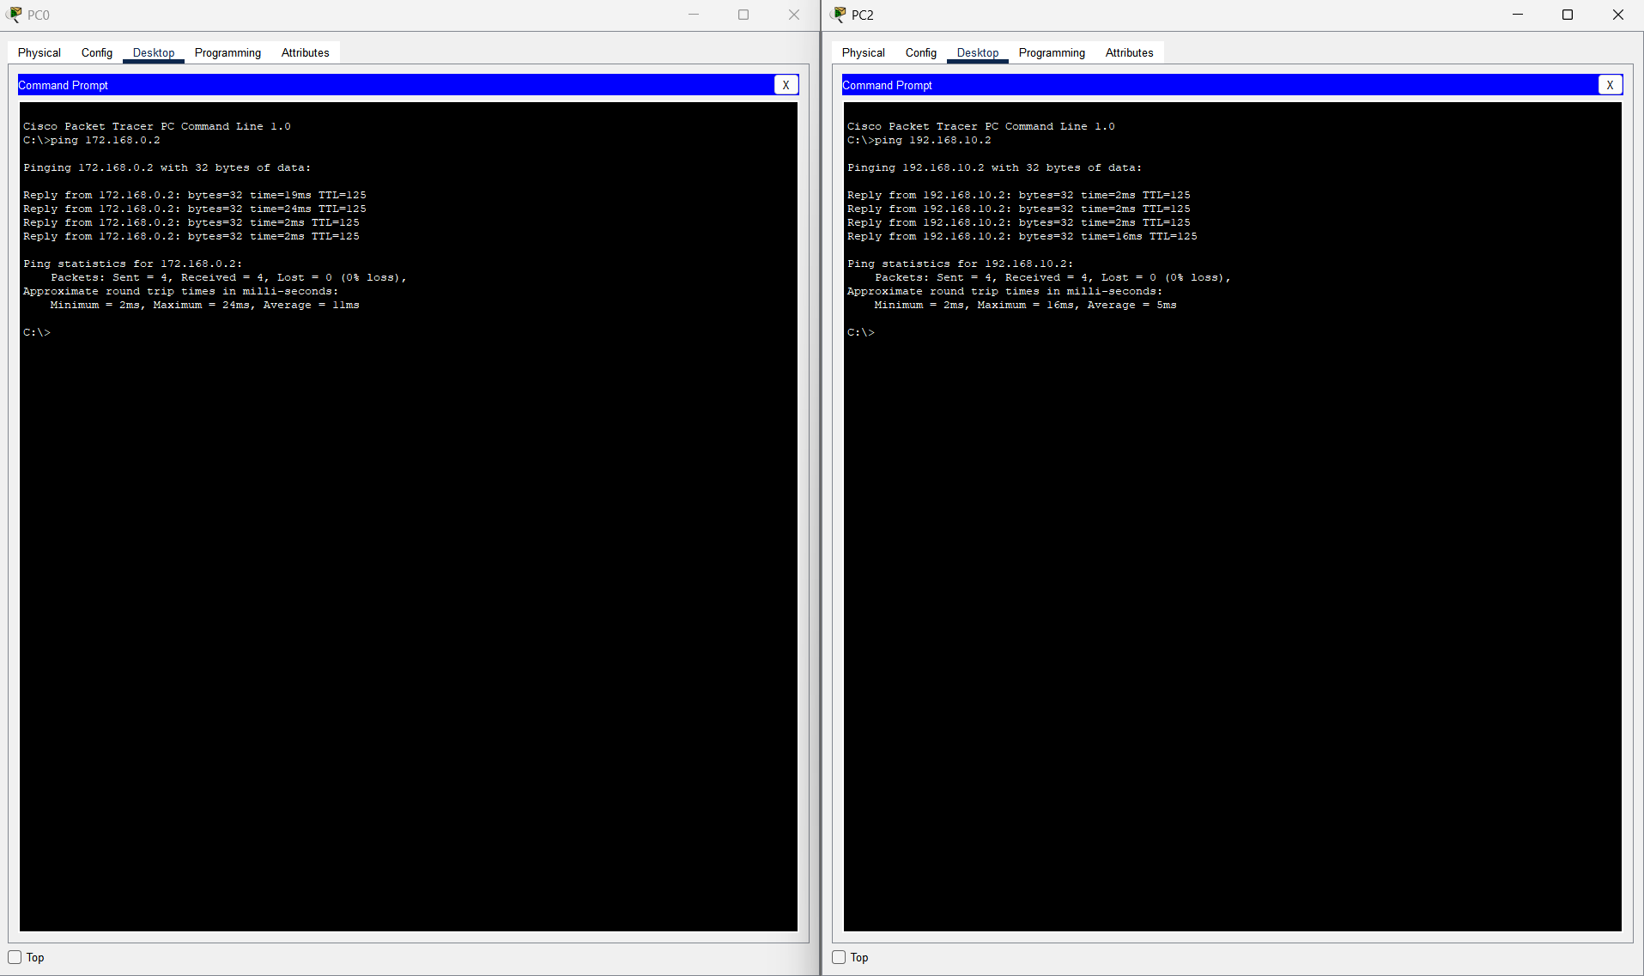

Configuring IPSEC VPN
Enabling security technology package on Site A and Site B Router
Site A Router
Router#config t
Enter configuration commands, one per line. End with CNTL/Z.
Router(config)#license boot module c2900 technology-package securityk9
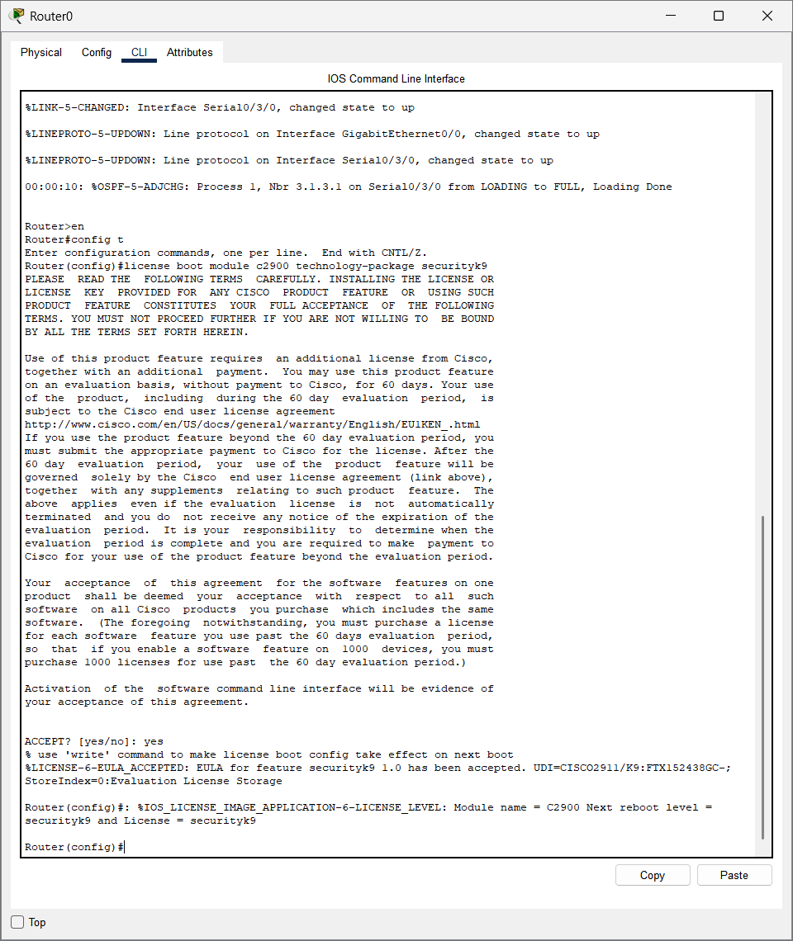

Site B Router
Router>en
Router#config t
Enter configuration commands, one per line. End with CNTL/Z.
Router(config)#license boot module c2900 technology-package securityk9
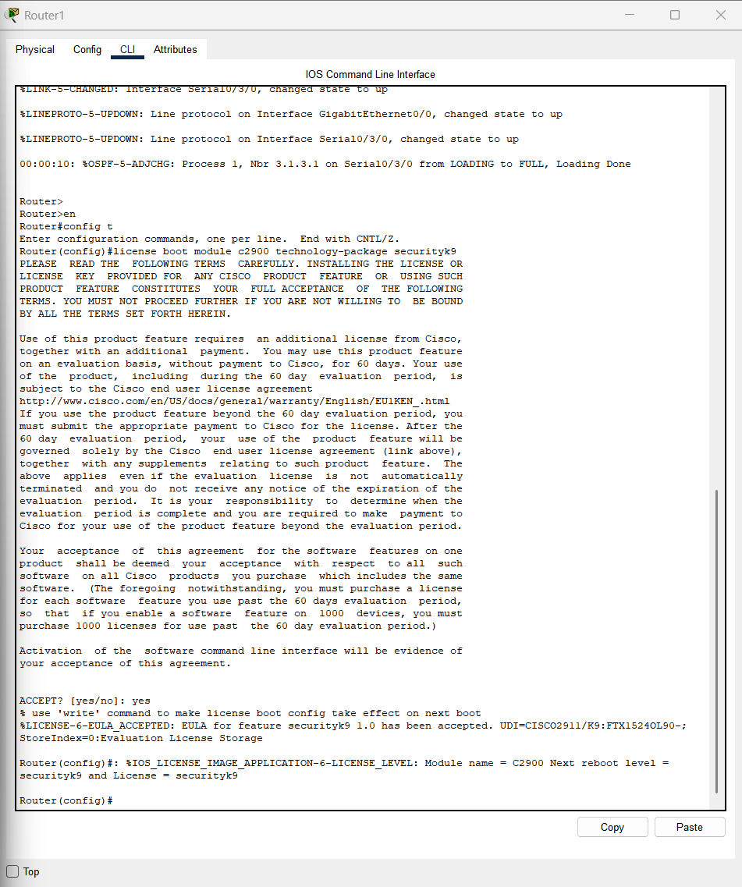

Verification security technology package enabled on Site A and Site B Router
Router#show version
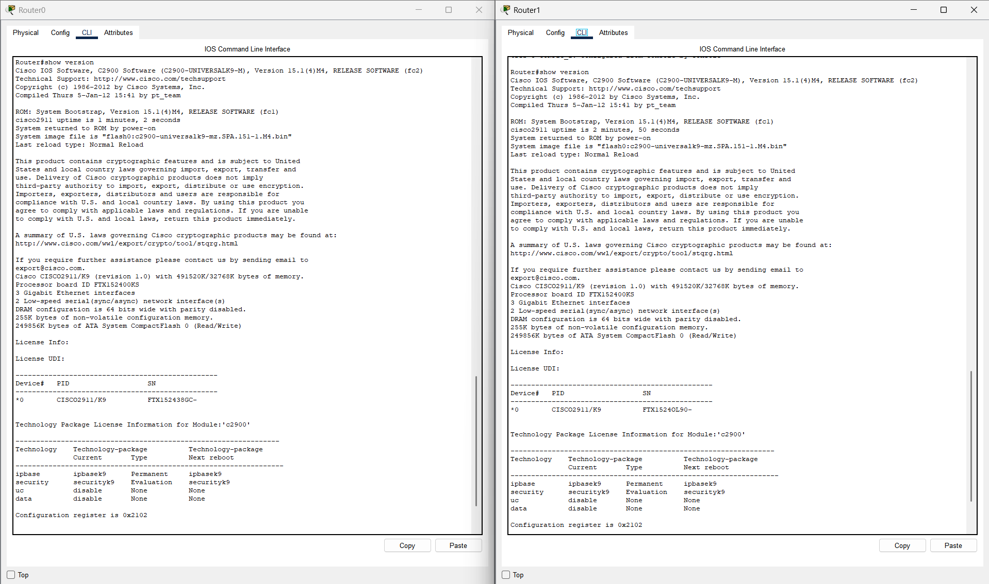

Configuring Extended ACL
Site A Router
Router#config t
Enter configuration commands, one per line. End with CNTL/Z.
Router(config)#access-list 130 permit 192.168.10.0 0.0.0.31 172.168.0.0 0.0.0.31
^
% Invalid input detected at '^' marker.
Router(config)#access-list 130 permit ip 192.168.10.0 0.0.0.31 172.168.0.0 0.0.0.31
Router(config)#exit
Router#
%SYS-5-CONFIG_I: Configured from console by console

Router#

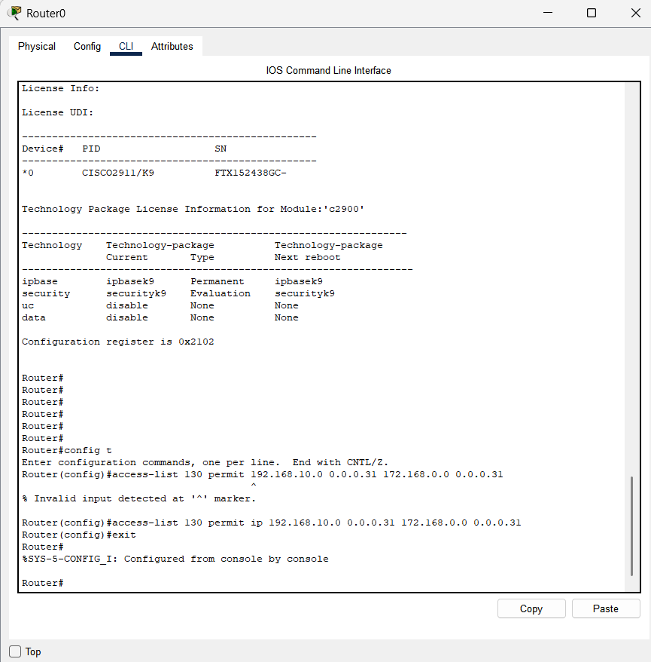

Site B Router
Router>
Router>en
Router#config t
Enter configuration commands, one per line. End with CNTL/Z.
Router(config)#access-list 130 permit ip 172.168.0.0 0.0.0.31 192.168.10.0 0.0.0.31
Router(config)#exit
Router#
%SYS-5-CONFIG_I: Configured from console by console
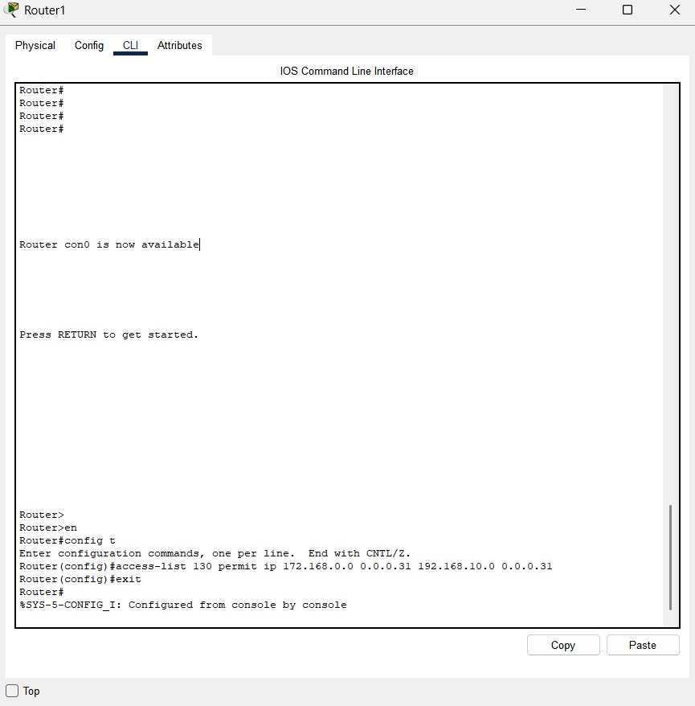

Configuring IKE Phase 1 ISAKMP Policy on Site A and B routers
Site A Router
Router>en
Router#config t
Enter configuration commands, one per line. End with CNTL/Z.
Router(config)#crypto isakmp policy 10
Router(config-isakmp)#encryption aes 256
Router(config-isakmp)#authentication pre-share
Router(config-isakmp)#group 5
Router(config-isakmp)#exit
Router(config)#crypto isakmp key tm45 address 20.20.20.2
Router(config)#do wr
Building configuration...
[OK]
Router(config)#

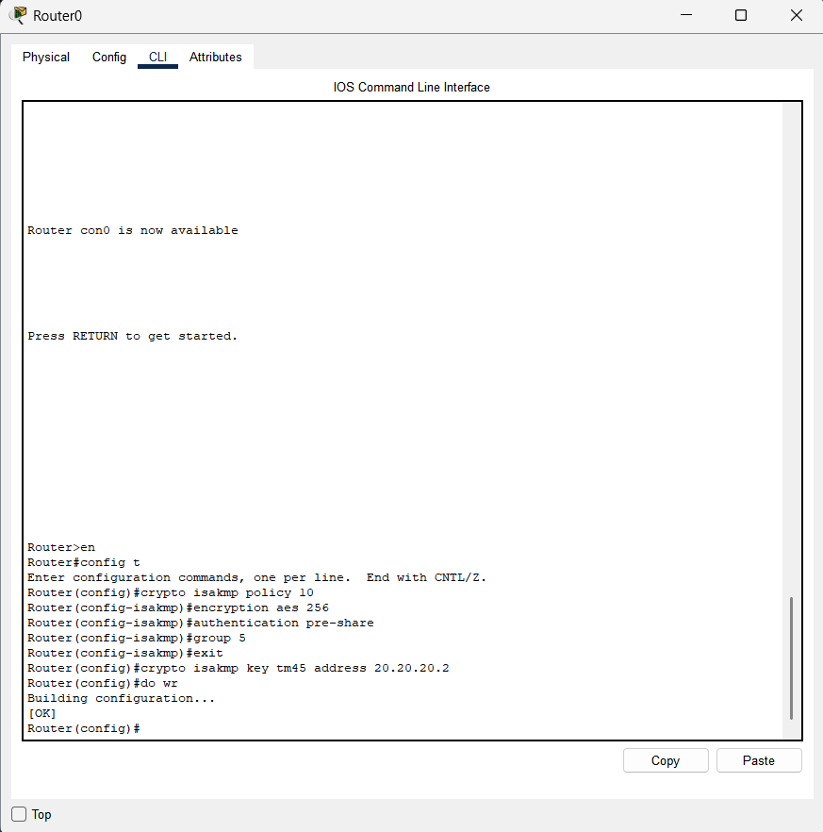

Site B Router
Router>en
Router#config t
Enter configuration commands, one per line. End with CNTL/Z.
Router(config)#crypto isakmp policy 10
Router(config-isakmp)#encryption aes 256
Router(config-isakmp)#authentication pre-share
Router(config-isakmp)#group 5
Router(config-isakmp)#exit
Router(config)#crypto isakmo key tm45 address 10.10.10.2
^
% Invalid input detected at '^' marker.
Router(config)#crypto isakmp key tm45 address 10.10.10.2
Router(config)#do wr
Building configuration...
[OK]
Router(config)#
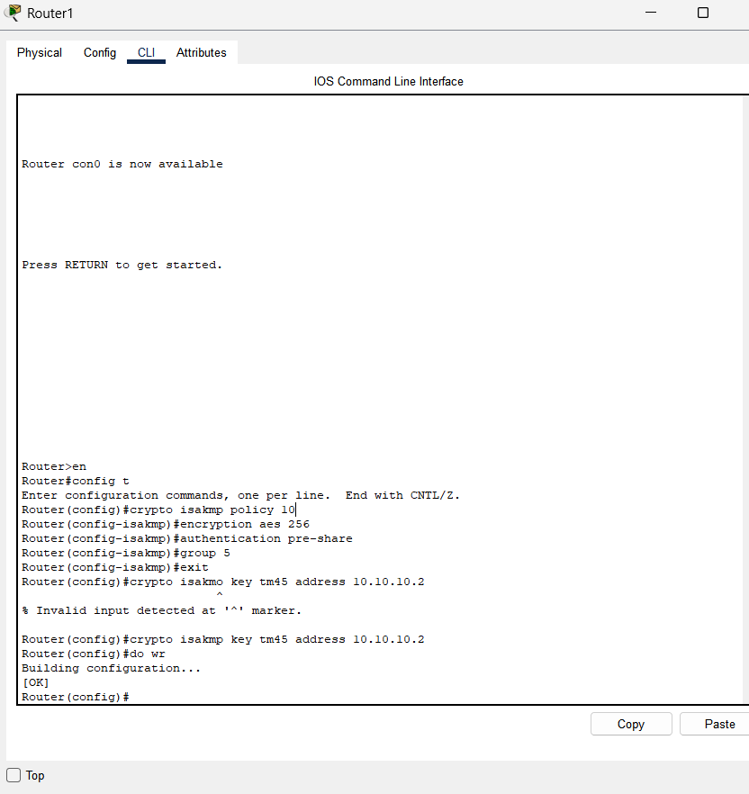
Configuring IKE Phase 2 IPsec Policy
Site A router
Router(config)#crypto ipsec transform-set VPN-SET esp-aes esp-sha-hmac
Router(config)#crypto map VPN-MAP 10 ipsec-isakpm
^
% Invalid input detected at '^' marker.
Router(config)#crypto map VPN-MAP 10 ipsec-isakpm
^
% Invalid input detected at '^' marker.
Router(config)#crypto map VPN-MAP 10 ipsec-isakmp
% NOTE: This new crypto map will remain disabled until a peer
and a valid access list have been configured.
Router(config-crypto-map)#
Router(config-crypto-map)#
Router(config-crypto-map)#description this VPN connects Site B branch
Router(config-crypto-map)#set peer 20.20.20.2
Router(config-crypto-map)#set transform-set VPN-SET
Router(config-crypto-map)#match address 130
Router(config-crypto-map)#exit
Router(config)#do wr
Building configuration...
[OK]

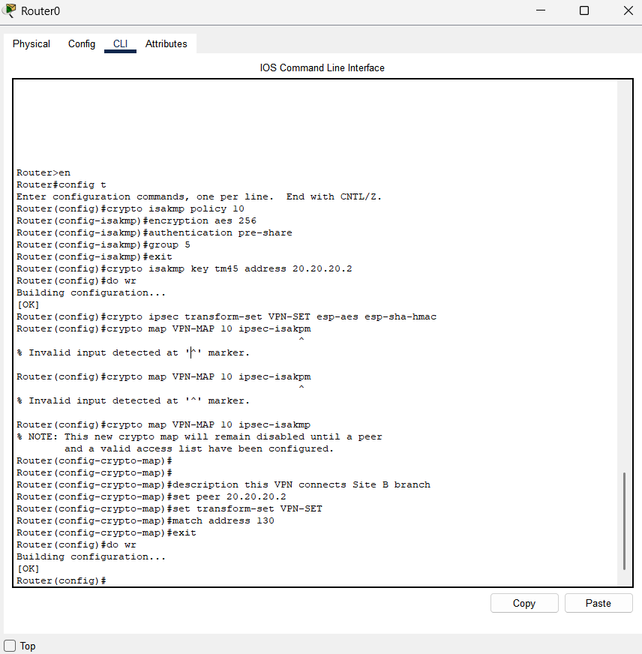

Site B Router
Router>en
Router#config t
Enter configuration commands, one per line. End with CNTL/Z.
Router(config)#crypto ipsec transform-set VPN-SET esp-aes esp-sha-hmac
Router(config)#crypto map VPN-MAP 10 ipsec-isakmp
% NOTE: This new crypto map will remain disabled until a peer
and a valid access list have been configured.
Router(config-crypto-map)#description This connects to site B
Router(config-crypto-map)#set peer 10.10.10.2
Router(config-crypto-map)#set transform-set VPN-SET
Router(config-crypto-map)#match address 130
Router(config-crypto-map)#exit
Router(config)#do wr
Building configuration...
[OK]
Router(config)#

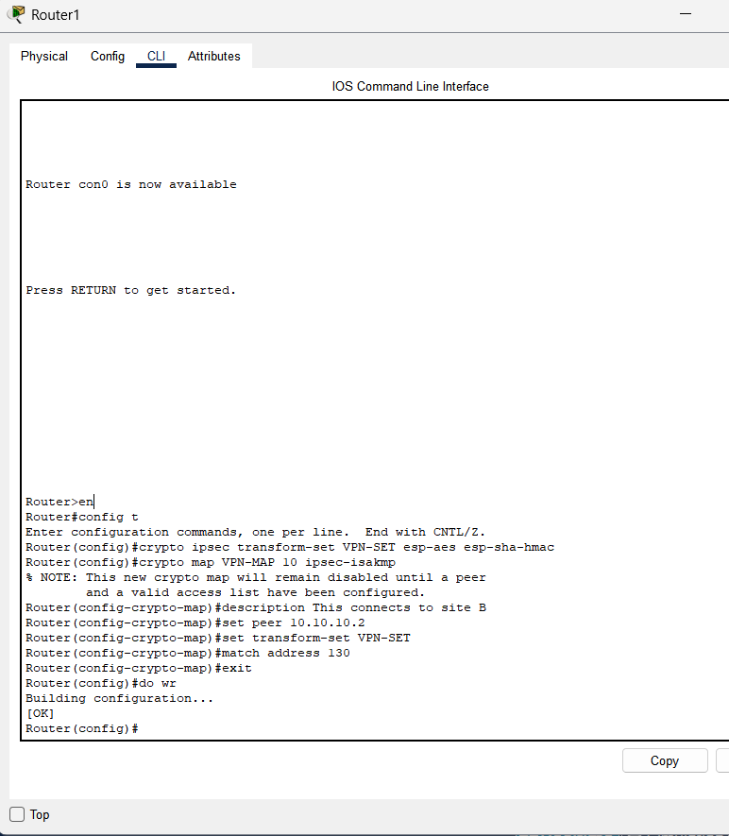
Configuring Crypto Map
Site A Router
Router(config)#int se0/3/0
Router(config-if)#crypto map VPN-MAP
*Jan 3 07:16:26.785: %CRYPTO-6-ISAKMP_ON_OFF: ISAKMP is ON
Router(config-if)#do wr
Building configuration...
[OK]
Router(config-if)#
Router(config-if)#

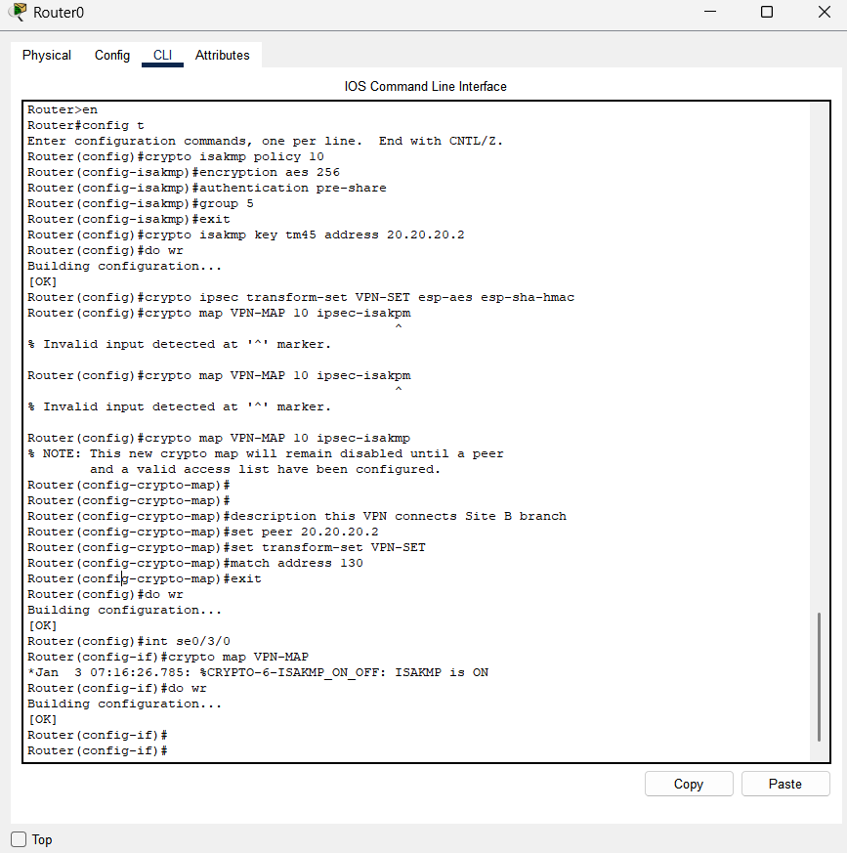

Site B Router
Router(config)#int se0/3/0
Router(config-if)#crypto map VPN-MAP
*Jan 3 07:16:26.785: %CRYPTO-6-ISAKMP_ON_OFF: ISAKMP is ON
Router(config-if)#exit
Router(config)#do wr
Building configuration...
[OK]
Router(config)#

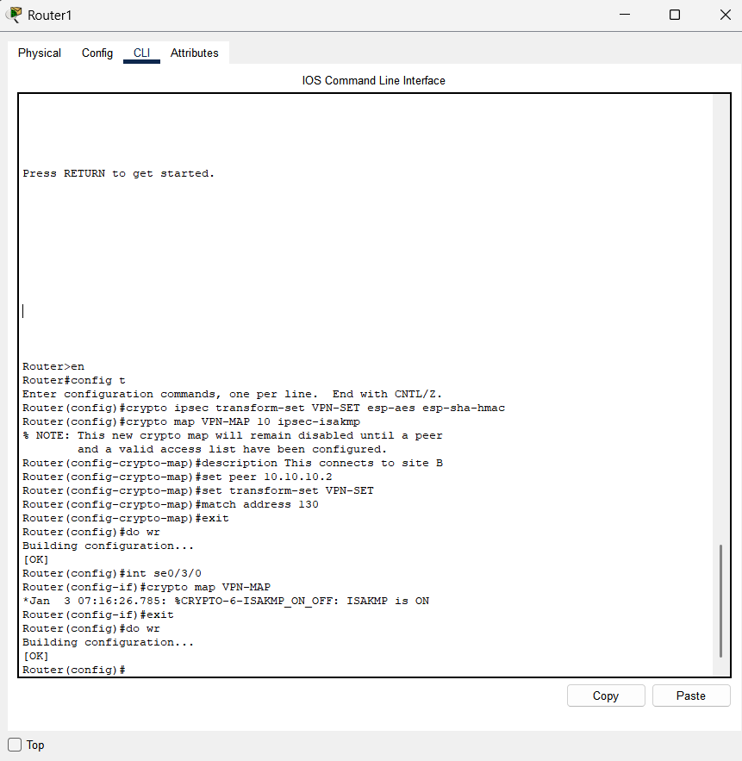
Verification of VPN working
Pinging Site B Pcs from Site A Branch
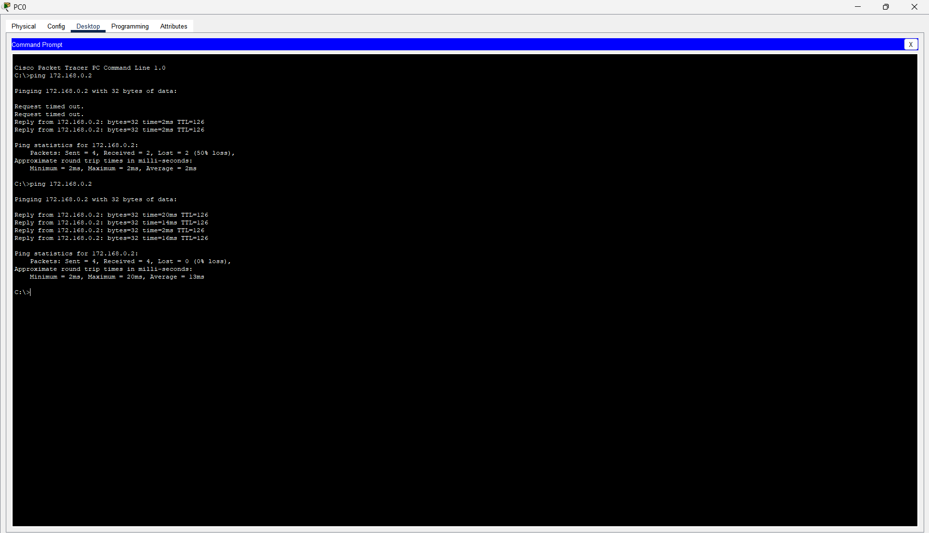

Verification of VPN configuration working as intended
Router>en
Router#sh crypto ipsec sa
